**Tracking Branches:**

* A tracking branch is the local branch that represents a remote branch. <remote>/<branch>
* For Example, the remote repository contains a master branch with 3 commits and head reference points to the default branch that will be checked out when repository is cloned.
* In this case, the default branch is master. When the repository is cloned to local, the master branch label and head reference will be copied to the local repository.

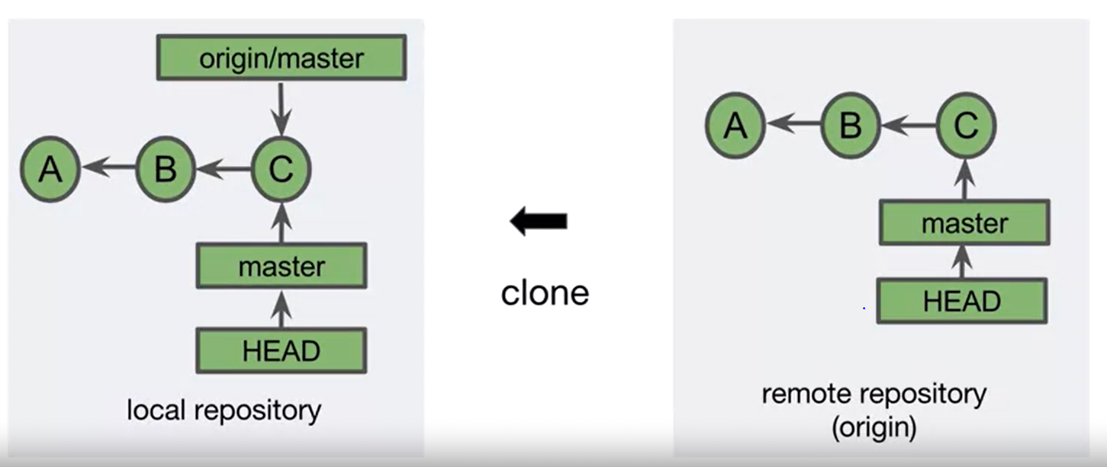

* After the clone, you will have master branch checkedout.
* You can see there is an addition branch named origin/master. This is the tracking branch. Origin represents the shortcut to the url of the remote repository.
* As the clone just happened, these two are synchronous.

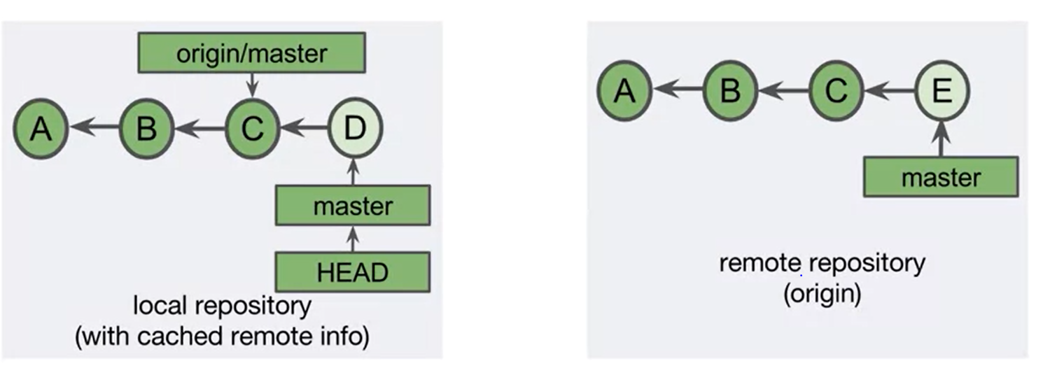

* The tracking branch is related to the associated remote branch and local branch, but they are decoupled.
* Tracking branches updates separately from both the remote branch and the local branch.
* This is because tracking branches are only updated with network commands like clone, fetch, push and pull.
* The tracking branches act as a sort of intermediary between the local and remote branches.
* In the above example, our tracking branch points to C. This means that at the time of the most recent network command. Latest, Commit C was the recent commit on the remote master branch.
* Locally, we then created Commit D. This moves the head reference and master branch label to commit D. The tracking branch label stays behind, as it moves only with network commands.
* Committing is a local command. We could see now that someone has made a Commit E at the remote branch. So, now we have 3 commits- The local branch-D, the master tracking branch label points to commit C and the remote master branch label points to commit E.
* The three related branches are no longer in sync.

**Viewing tracking branch names:**

* By default, the git branch command only lists the names of the local branches.

Command: git branch –-all

* Use the above command to display all local and tracking branch names.

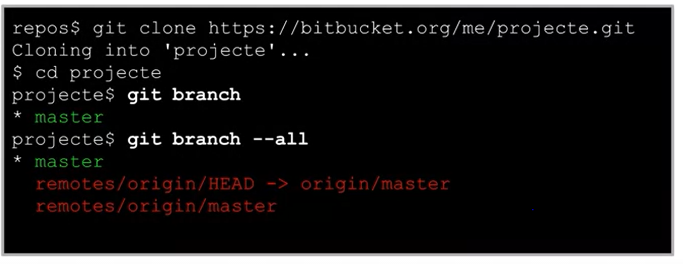

* When you specify a git branch –all it gives you a master branch and another branch which is a symbolic reference to the existing branch and the last one is the tracking branch.
* Above, only first and third lines represent unique branches.
* Remote/origin/Head is a symbolic reference meaning a reference pointing to another reference. This specifies the default remote tracking name.
* This allows you to write only the remote name instead of the whole tracking branch name in git commands.

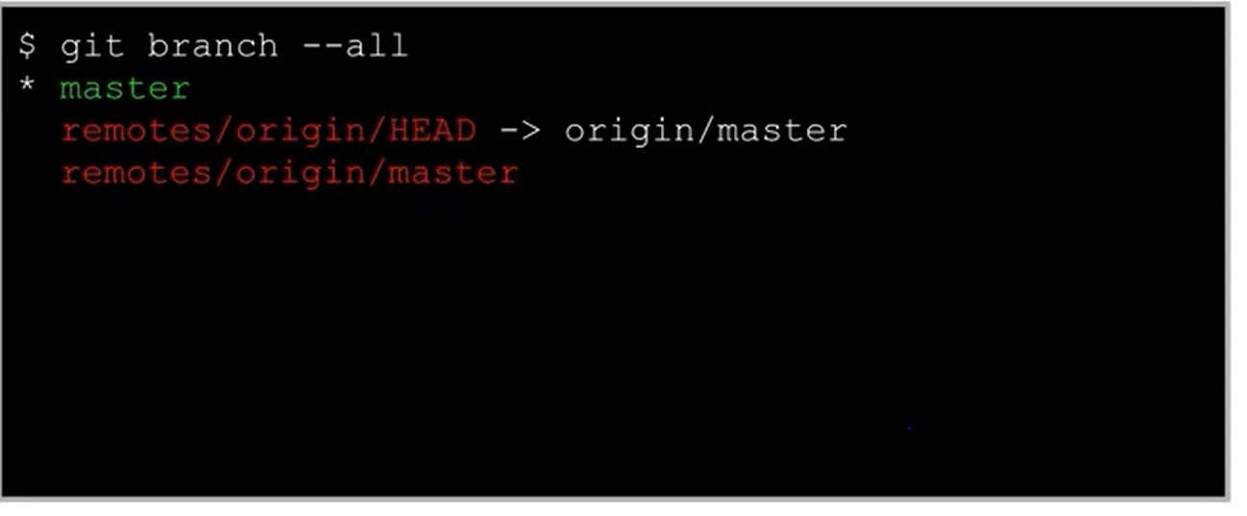

* Above, we have one local branch name as master and it is checked out. The default remote tracking branch has been set to origin/master.
* The third line says that the master branch has been set up as tracking branch.
* You can change the default remote tracking branch by using the set command.

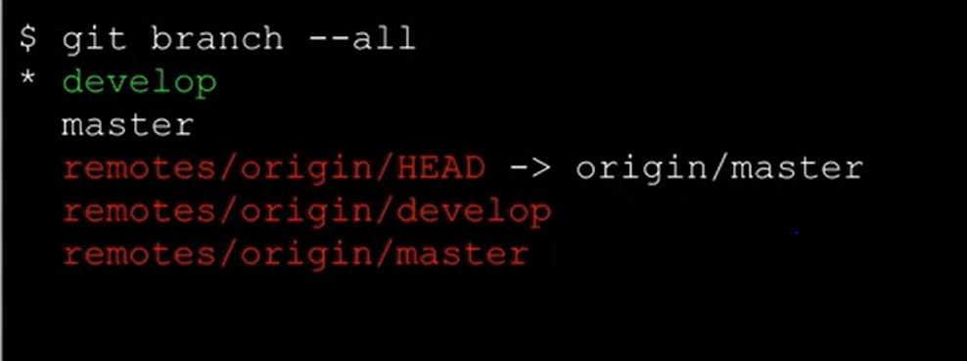

* The default remote tracking branch has been set to origin/master.
* The develop and master branches are set up as tracking branches.
* Command: git remote set-head origin develop
* Now the default branch is set to origin/develop.
* So now anywhere in git commands we can specify only as origin instead of origin/develop.

**Viewing tracking branch status:**

* The “git status” will inform you if the cached tracking branch information is out of sync will local branch.
* The tracking branch is representation of the associated branch on the remote repository.
* To view the status of all local and tracking branches use the command git log –all.
* Tracking branches are the local branches that represent the remote branches.
* They are named remote/branch
* Can become out of sync with local branches.
* Updated with the network commands like clone, fetch, pull and push.

**Fetch, Pull and Push:**

* Clone: Copies a remote repository.
* Fetch: Retrieves new objects and references from another remote repository. It mainly updates all the tracking branch information. It allows to download and view changes on a remote repository.
* Pull: Fetches and merges commits locally
* Push: Adds new objects and references to the remote repository.

**Git Fetch:**

* The git fetch command retrieves new objects and references from another repository.
* It mainly updates all of your tracking branch information.
* If the repository argument isn’t specified and you have only one remote repository setup locally, that remote repository will be used by default.
* Git fetch allows you to download and view changes on the remote repository without having them to immediately merge them with your current work.

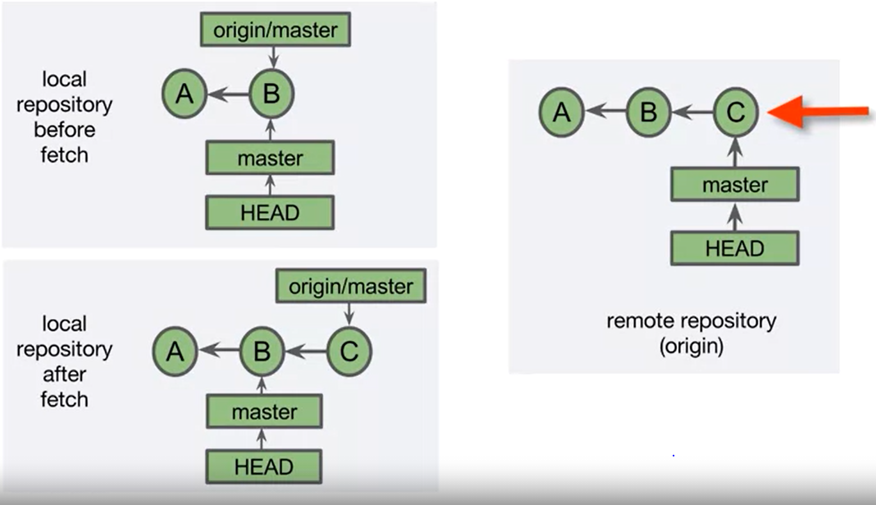

* We start with local repository with two commits on a single branch.
* The master branch label and the tracking branch label both point to commit B
* The remote repository has one more commit C. This was created after our most recent network command.
* After we execute the fetch, the local repository has all of the commits and references from the remote repository but they are on the tracking branch.
* Our local branch hasn’t moved to recent because of the fetch.
* Fetch doesn’t impact local branch labels.
* After the fetch, the tracking branch has the same commits as the remote repository’s master branch.
* The git status will inform you that your current branch is behind the tracking branch.

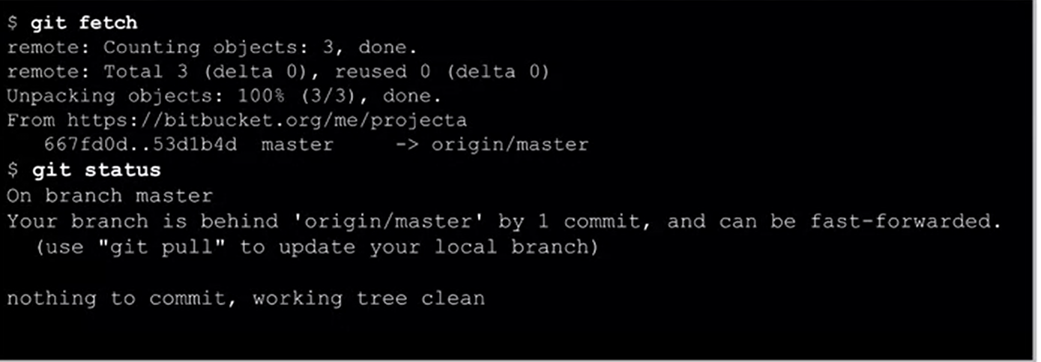

**Git Pull:**

* Git pull is the network command that combines git fetch and git merge FETCH_HEAD.
* FETCH_HEAD is an alias name for the tip of the tracking branch.
* First, new objects and references from the remote repository are fetched.
* If new objects are added to the tracking branch, the tracking branch is merged into the local branch.
* The current branch is assumed if branch isn’t specified.

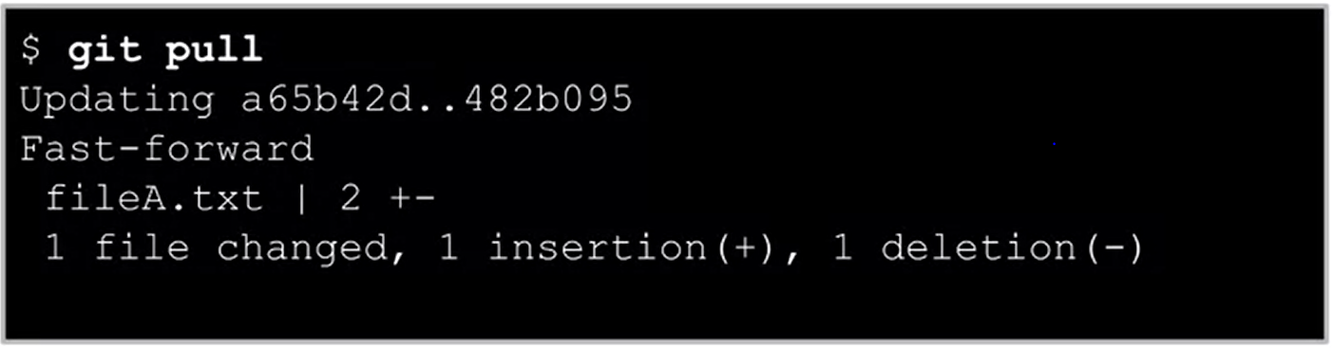

* In this case, one file was fetched. You can see that a fast forward merge occurred and changes to file a text were made.
* You are now in sync with remote repository.
* You can specify merging options while doing a pull:

--ff(default): fast forward if possible otherwise perform a merge commit.

--no-ff: Always include a merge commit.

--ff-only: cancel instead of doing a merge commit.

--rebase: (--preserve-merges)

**Pull with Fast Forward Merge:**

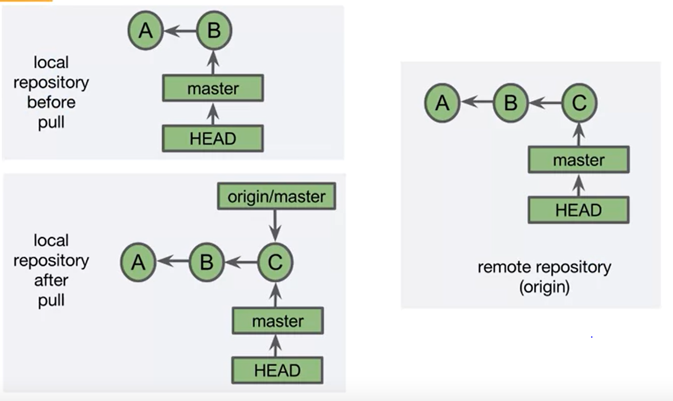

* Here, the local repository has 2 commits and the remote repository has a third commit
* If we perform a pull, commit c will be fetched and tracking branch label will be updated to C.
* Because we haven’t made any commits to the master branch locally that aren’t on local repository, a fast forward merge is performed.
* This simply moves the master branch and Head reference to commit C.
* After executing the pull, the local and remote branches are synchronized.

**Pull with a Merge Commit:**

* Before the pull, we have the local repository with three commits A< B, D

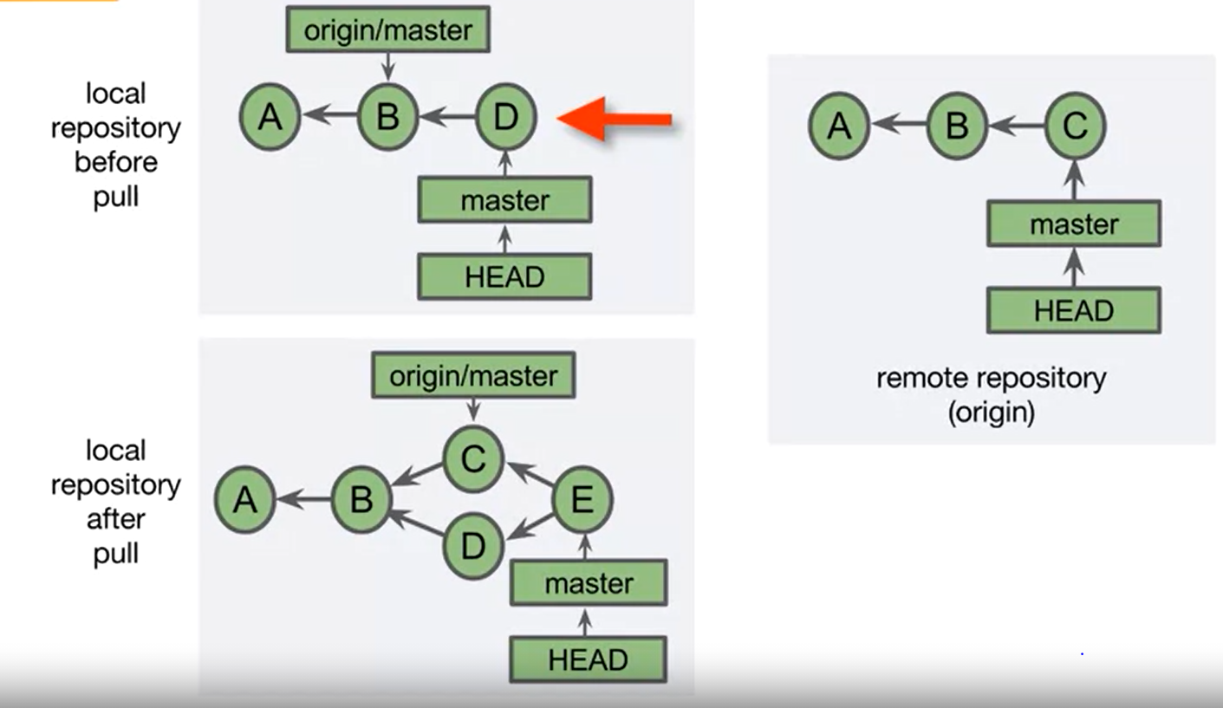

* The tracking branch points at B and the local master branch points to D.
* The remote repository has 3 commits but the last commit is C
* When we first pull, a fetch happens Commit C is retrieved from origin and then the tracking branch label points to C.
* That is the same as the tip of the remote repository.
* After the fetch, the tracking branch is merged into the local master branch creating merge commit E.
* At this point, the remote repository doesn’t know that we have created a merge commit locally.

**Git Pull with Fast Forward Merge:**

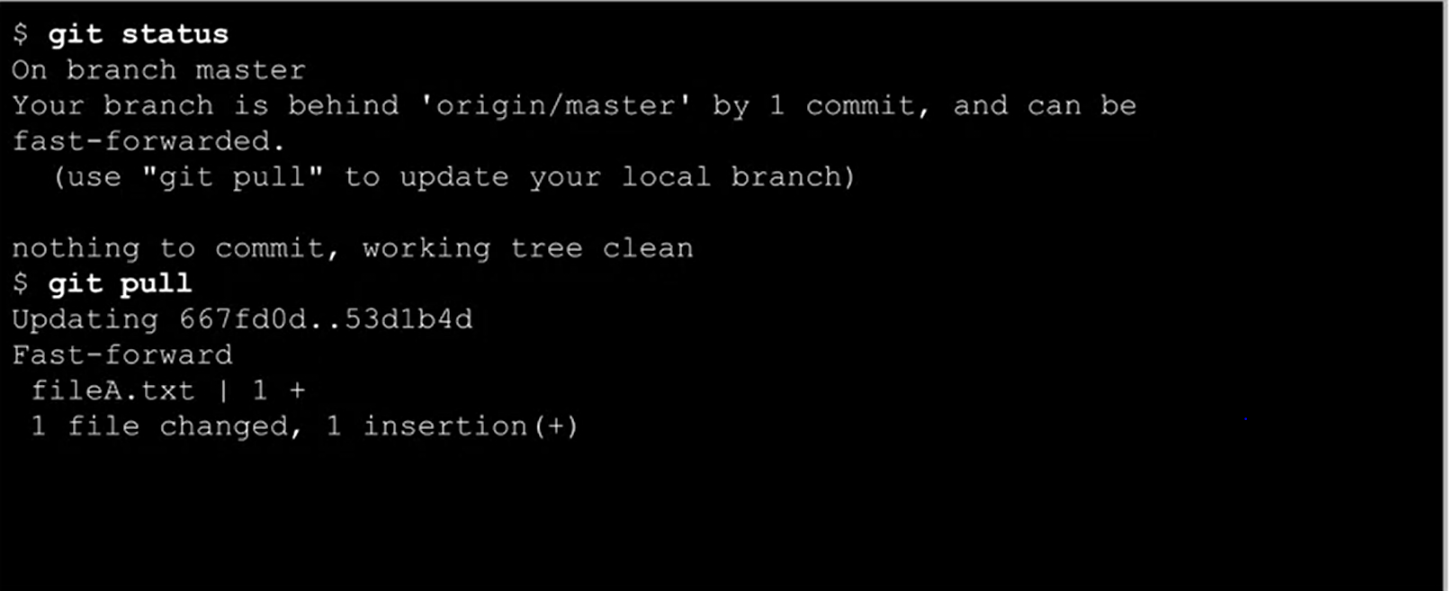

* Git fetches some objects and then try to do a merge. It notices that you have local changes to a file that it will be replacing.
* It suggests that you commit or stash your changes before the merge and then it aborts the merge.
* Stashing is a way to save files modified in the working tree for later access.
* Git pull only aborts the merge if you have uncommitted changes that would be overridden by git.
* If you have modified a file that’s not going to be replaces by git it lets the merge continue.

**The Tracking branch is like the Topic branch:**

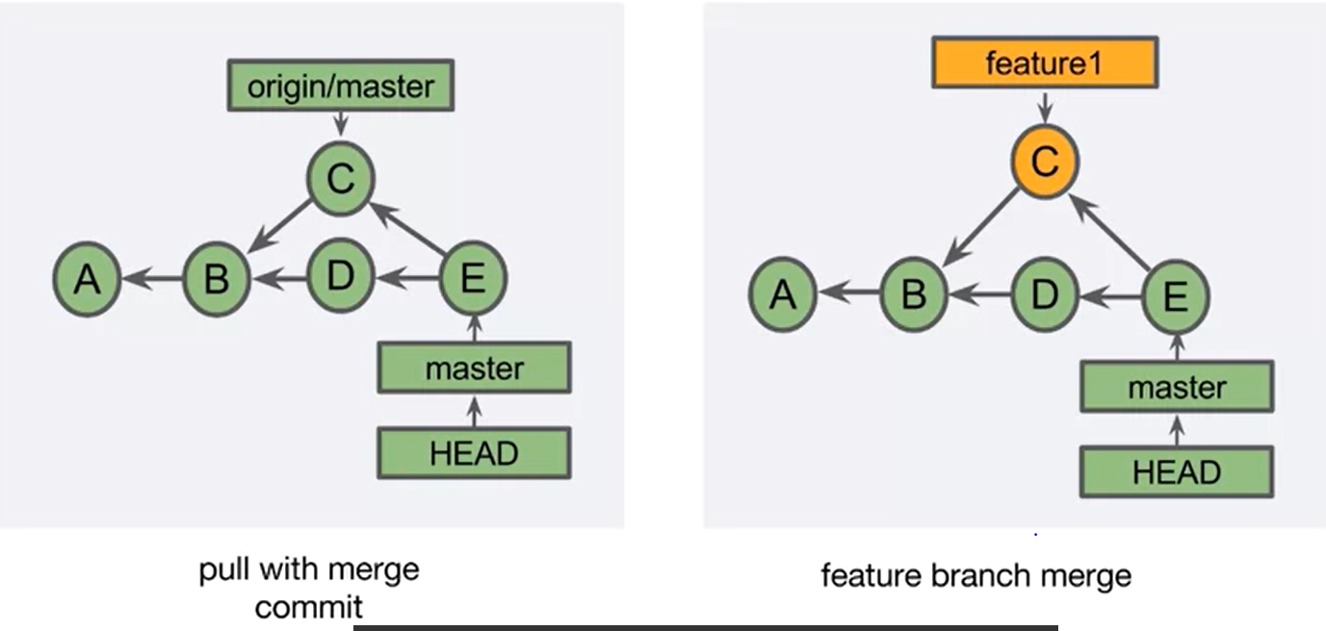

On the left we create a merge commit after pull. Notice that a merge commit was created even knowing that the only branch is the master branch. This is because the tip of the tracking branch is acting like a topic branch.

**Git Pull with merge:**

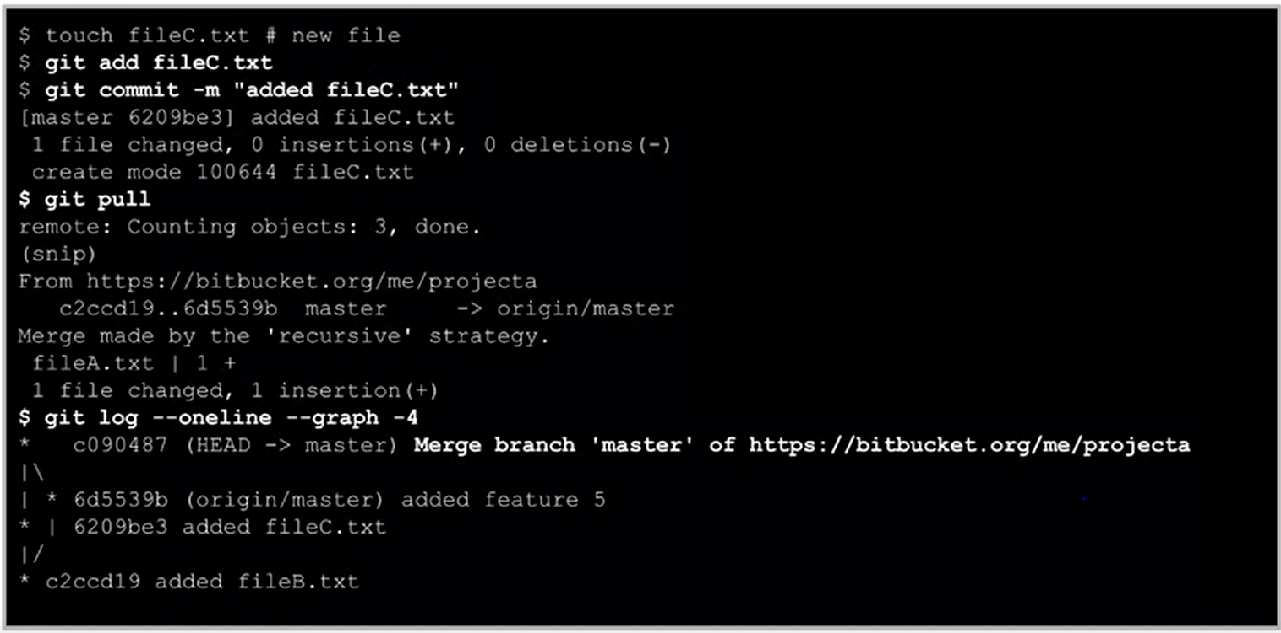

**Rebasing**:

* Rebase and Interactive Rebase
* Moves commits to a new parent(base)

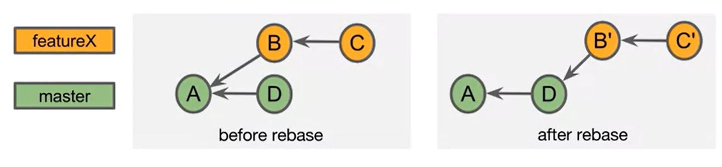

* The unique commits of the feature branch (B and C) are reapplied to the tip of the master branch(D).
* Because the ancestor chain is different, each of the reapplied commits has a different commitID(B’ and C’).
* What rebasing does is take commit B and C and moves to the new parent commit D. The result is that we no longer need a merge commit and the merge can be fast forwarded.
* Because the commits have been moved, they are reapplied on top of the new commit. This creates a different ancestor chain and as result each of the commit-ID’s change.

**DIFFS:**

* Each commit contains a snapshot of the complete project.
* Git can calculate the difference between the commits. This is known as a diff or a patch.
* We know that each commit contains snapshot of the project.

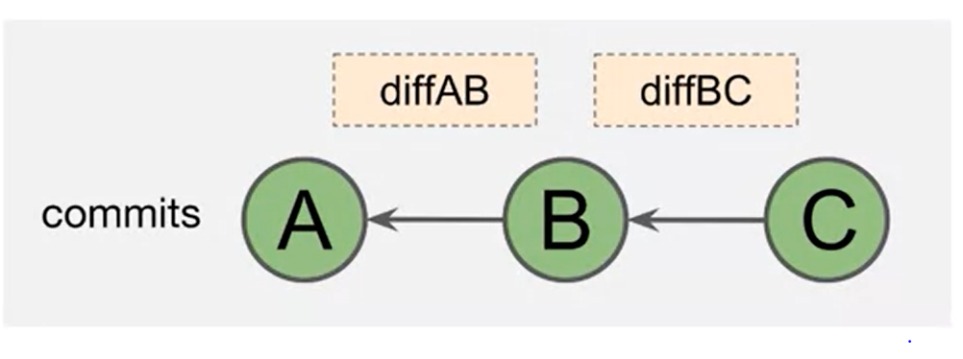

So, Commit A has the entire project. A different between A and B & A&C is taken.

**Rebasing reapplies commits:**

* When rebasing, Git applies the diffs to the new parent commit. This is called “reapplying commits”.
* In before commit, we can see that the parent of B is A and parent of C is B. With rebasing, Git takes the difference between A and B and applies it with a parent of commit D. This creates a new Commit ID. It then applies the difference between commits B and C and creates Commit C prime.
* Reapplying commits is a form of merge and is susceptible to merge conflicts.

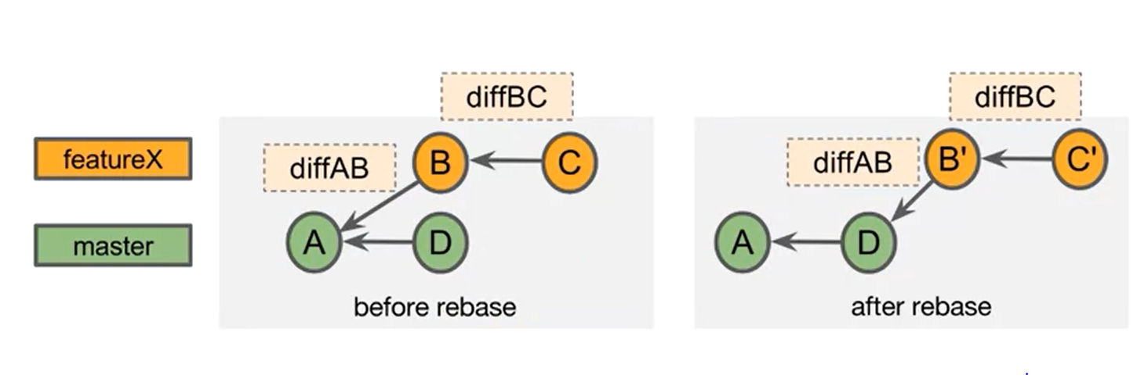

* See below, commits B and C can change the same file, causing a merge conflict during the rebase.

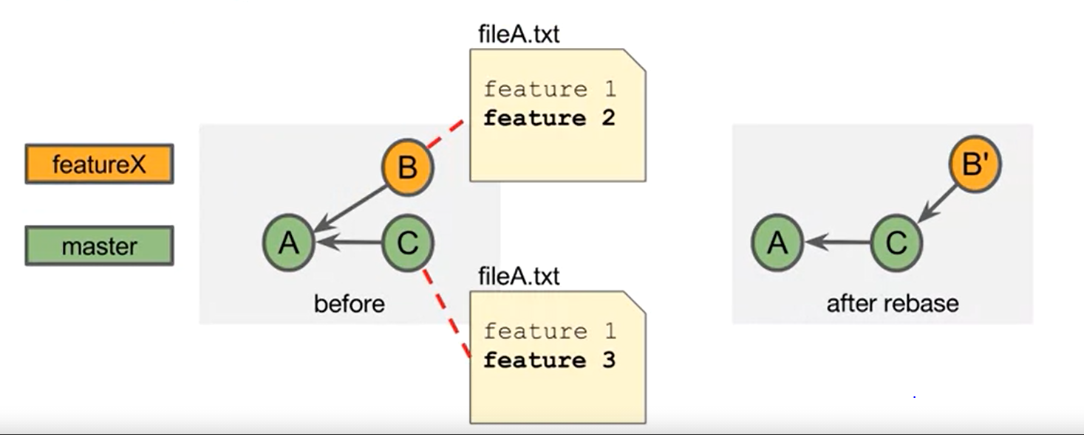

**Rebasing Pros and Cons:**

**Pros:**

* You can incorporate changes from the parent branch.
* You can use the new features/bugfixes.
* Tests are on more current code.
* It makes the eventual merge into master fast-forwardable.
* Avoids unnecessary commits.
* It allows you to shape/define clean commit histories.

**Cons:**

* Merge conflicts may need to be resolved.
* It can cause problems if your commits have been shared.
* You aren’t preserving commit history.

**Executing a Rebase:**

* There are two basic ways that you can execute a git rebase.
* The first is to checkout the feature branch and execute “git rebase” specifying the upstream argument which is something like master branch.
* This will change the parent of the checked out branch to the tip of the upstream branch.
* In the second option you don’t need to checkout the feature branch first, you specify it as the second argument of the git rebase command.

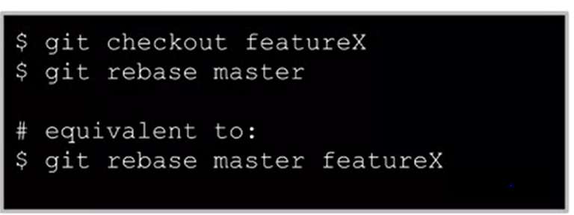

**Rebasing with Merge Conflicts:**

* Rebasing is a form of merge, merge conflicts can arise and what happens is you checkout the feature branch, execute the git rebase master and git informs you that there is a merge conflict.
* You can execute git status and see that.
* Example of a rebase with merge conflict:

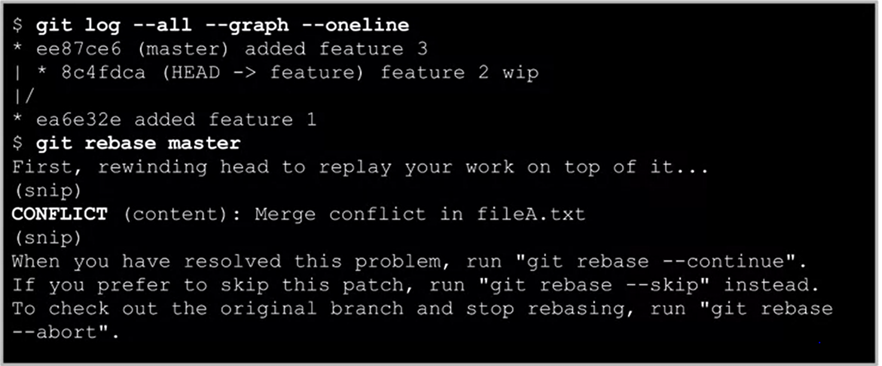

* You can use “git rebase continue” after the merge is resolved and see that we have a nice linear graph.
* If you rebase and find a merge conflict then you can use the abort option to get back to the pre-rebase state.

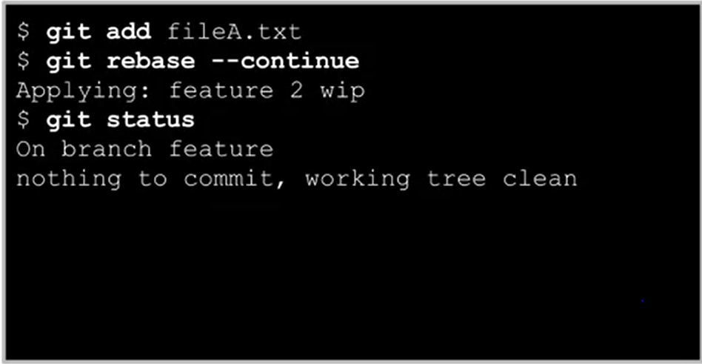

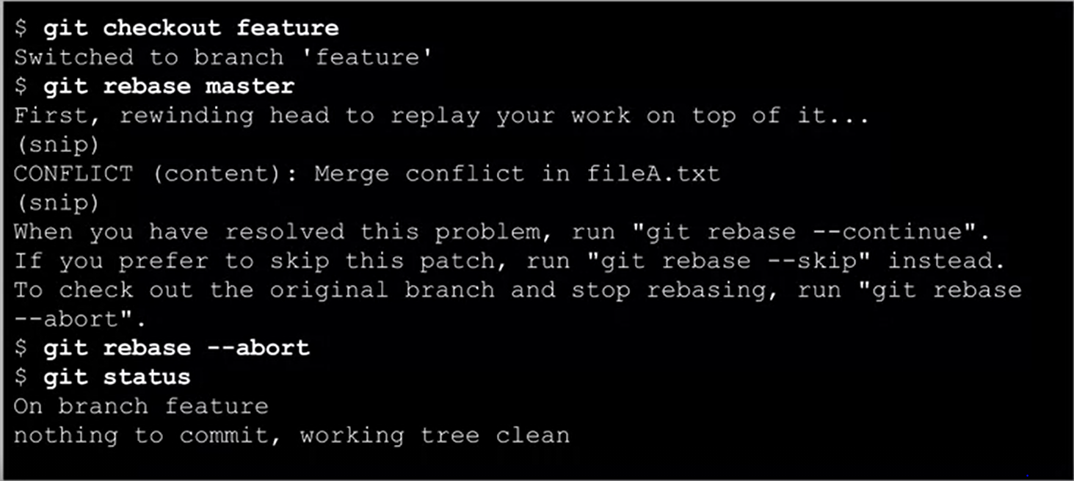

**Compare Merge and Rebase:**

|  |  |  |
| --- | --- | --- |
| S.No | Merge | Rebase |
| 1 | Git checkout master | Git checkout feature |
| 2 | Git merge feature(conflict) | Git rebase master(conflict) |
| 3 | Git status | Git status |
| 4 | Fix file | Fix file |
| 5 | Git add fileA.txt | Git add fileA.txt |
| 6 | Git commit | Git rebase --continue |

**Rewriting History:**

**Amending a Commit:**

* You can change the most recent commit. Change the commit message, change the project files.
* This creates a new SHA-1(rewrites history).

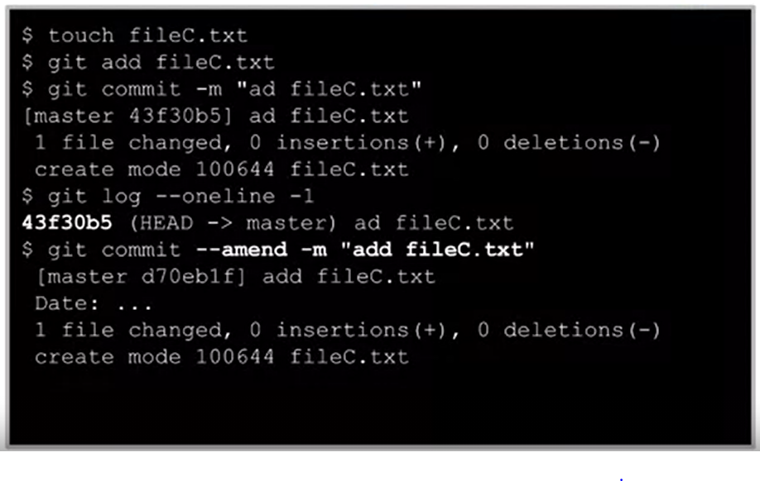

**Interactive Rebase:**

* Interactive rebase lets you edit commits using commands.
* The commits can belong to any branch.
* The commit history is changes – donot use for shared commits.
* Commits in the current branch after this commit are listed in an editor and can be modified.

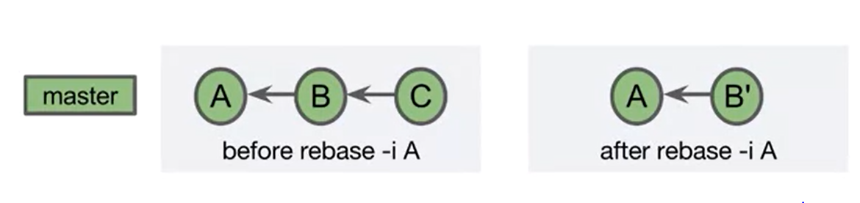

* Interactive rebase options are:
* Use the commit as is
* Edit the commit message
* Stop and edit the commit
* Drop/delete the commit
* Squash
* Fixup
* Reorder commits
* Execute shell commands

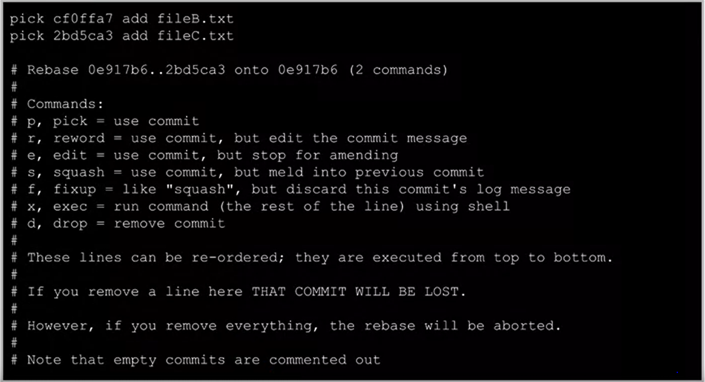

**Delete a commit:**

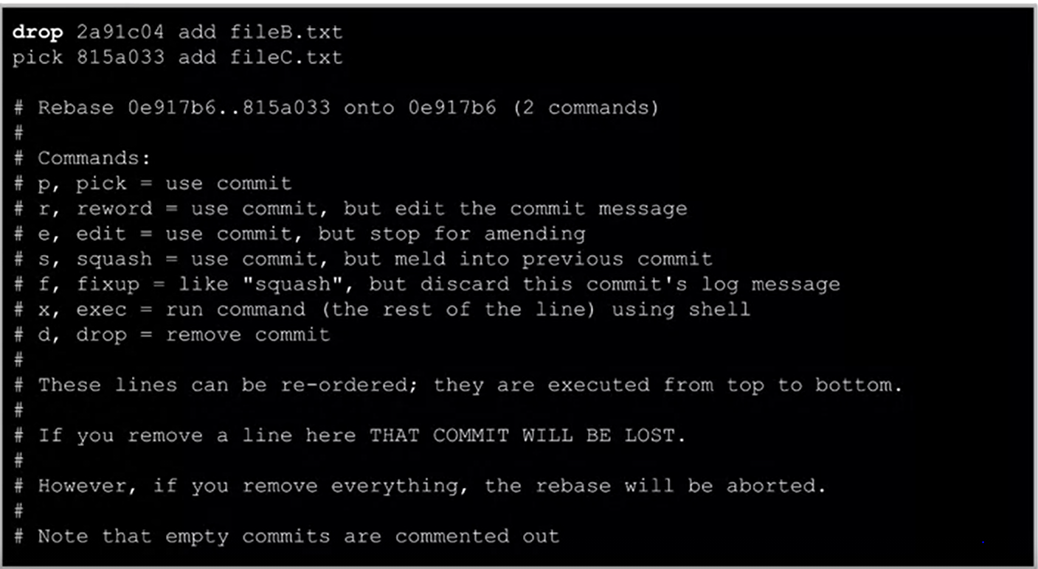

**Squash a Commit:**

* Applies a newer(squashed) commit to an older commit.
* Combines the commit messages.
* Removes the newer commit.
* A fixup is like a squash, but squashed commit’s message is discarded.
* We execute an interactive rebase such that we can work on its children.
* Squashing will result in work not being lost.

**Squash vs Delete:**

* **Squash:** Combine this commit with the older commit creating a single commit. The work of both commits included.
* **Delete:** No changes from this commit are applied. The diff is thrown out. The work of this commit is lost. Greater chance of a merge conflict.

**Squash Merges:**

* Merges the tip of the feature branch(D) onto the tip of the base branch(C). There is a chance of merge conflict.
* Places the result in the staging area.
* The result can then be committed€.

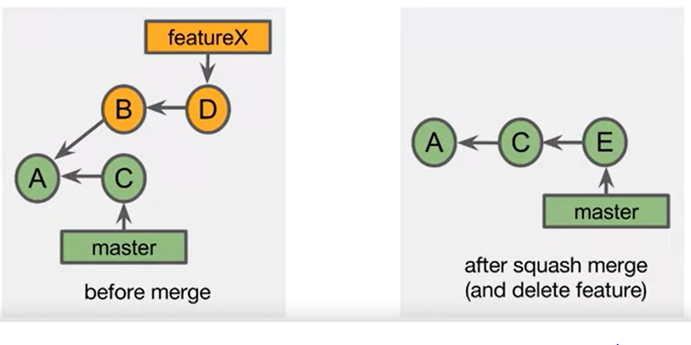

**What happens to the feature commits:**

* After the featureX is deleted, commits B and D are no longer part of the named branch.
* Commits B and D will eventually be garbage collected.
* A squash merge rewrites the commit history.

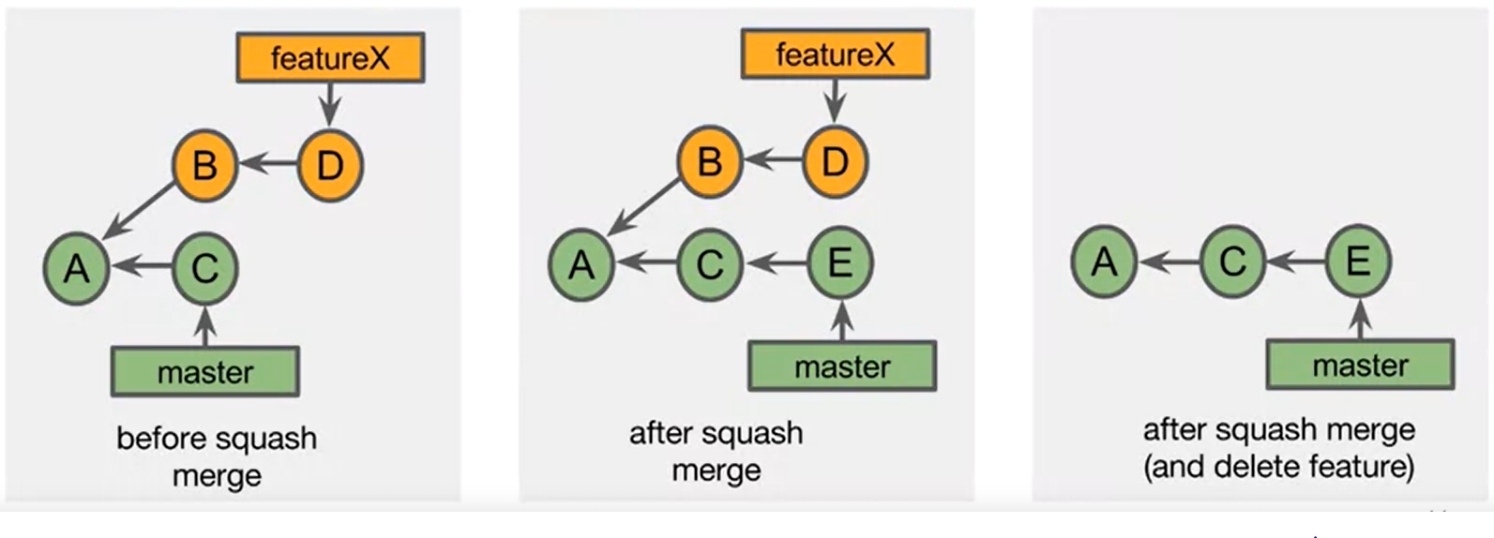

* To perform a squash merge:
* Git checkout merge
* Git merge –squash featureX.
* Git commit(Accept or modify the squash merge)
* git branch -D featureX.

**Pull Requests:**

* Pull requests are a feature of Git hosting sites such as BitBucket and Github.
* The ultimate goal of a pull request is to merge a branch into the project.
* Pull requests enable team communication related to the work of the branch.
* Notifications related to the pull request can be sent to the team members.
* Those team members can provide feedback or comments and ultimately can have a say in approving the content.
* There are two basic repository configurations related to the pull requests.
* The first is the single remote repository. A pull request in single level repository configuration is a request to merge a branch of the repository.
* The second configuration involves 2 remote repositories. In this configuration the pull request is a request to merge a branch from the forked repository into the upstream repository.
* The fork approach is common if the submitter doesn’t have write access to the upstream repository.
* You can open a pull request when you create the branch. This enables the team to begin discussion on the work of the branch immediately.
* You can also open pull request when you want comments on the branch.
* And finally, you can open the pull request when you think the branch is ready for review and merging.

**Single Repository Pull Requests:**

* Before making a pull request you need to prepare for the pull request.
* For this, you first create a feature branch. After the discussion or the branch work is ready you can push the branch to the remote repository.
* You will then be asked to select a merge strategy. You can create a merge commit or you can create squash.
* A squash will reduce the entire branch to one linear commit.

**Forking:**

* Forking generally means copying a remote repository to your own online account.
* It is a feature of git hosting services such as BitBucket and Github
* Both repositories are remote repositories.
* The upstream repository is usually considered the source of truth for the project.
* A fork can be used to experiment with or learn from upstream repository.
* You have a separate remote repository which can be synchronized with the upstream repository.
* A fork can also be used to create branches and issue pull requests to the upstream repository.

**Git Workflows:**

* A workflow defines how your team accomplishes work. Git is very flexible and can be tailored to many projects and teams.

**Centralized Workflow:**

* A centralized workflow uses a single branch to accomplish the work. All team members can work independently and each has local copy of the project history.

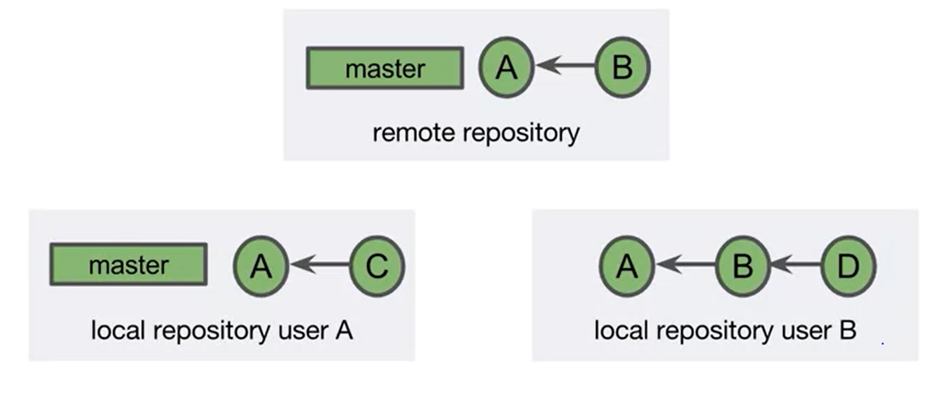

* A downside of the centralized workflow is that you are not taking advantage of features related to branching such as pull requests.

**Feature Branch Workflow:**

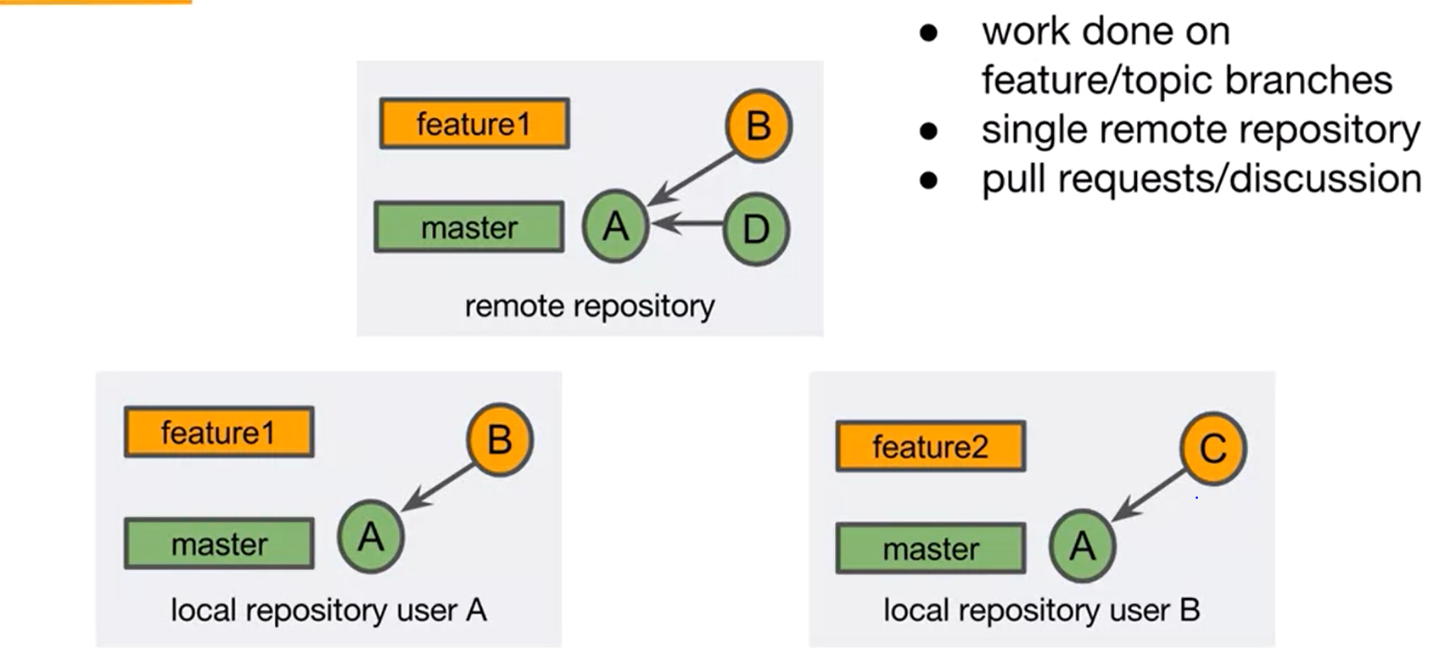

* In a feature branch workflow, the work of the project is done in feature or topic branches. The work is then merged into long running branch. It uses a single remote repository.

**Forking Workflow:**

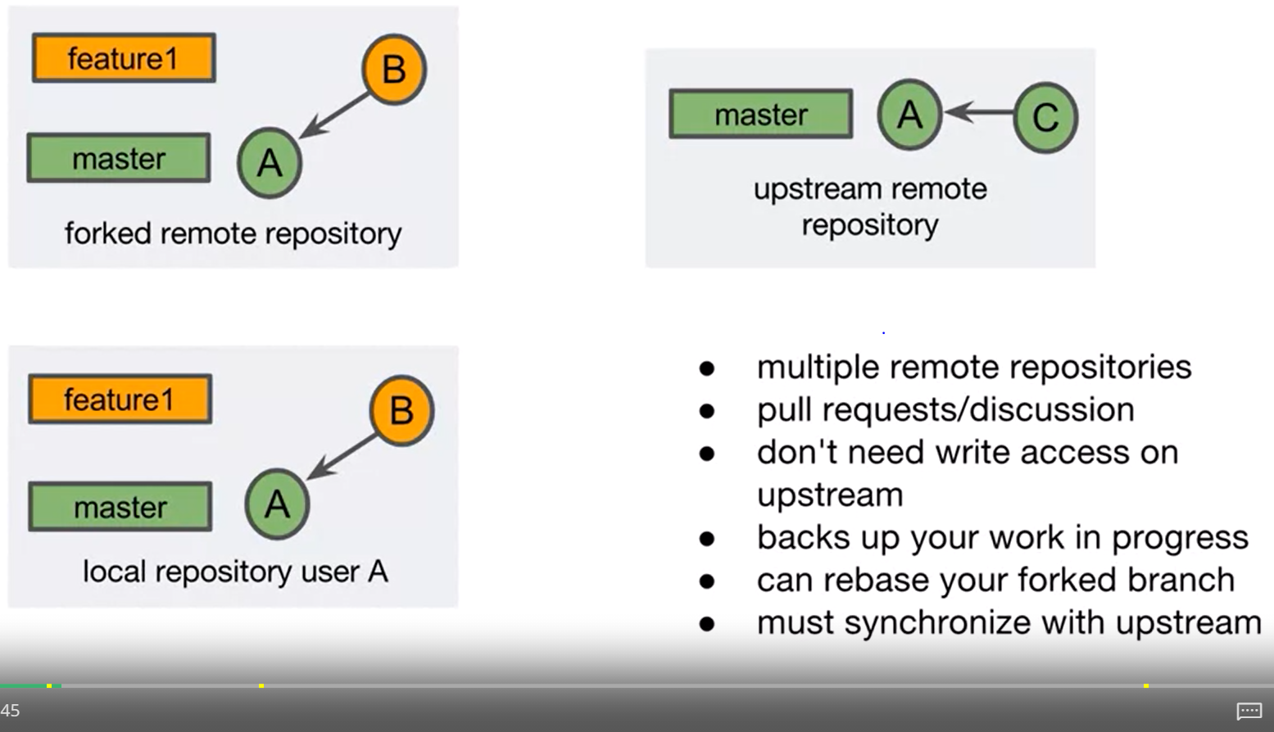

* This involves multiple remote repositories. One of the repositories is considered as upstream from the other.
* Work is usually transferred from the remote repository to the upstream repository via a pull request.
* One advantage of this workflow is that the user of the forked repository doesn’t need to have a write access to the upstream repository. This is because a user on the upstream repository merges the pull request.
* Because of this, the forking workflow is very common in open source projects.
* Forking a repository is a great way to work on the feature branch without sharing the branch.
* This provides a remote backup of your work and allows you to safely rebase your local branch.
* A downside of this approach is that the two remote repositories can become out of sync.
* It’s the responsibility of the forked repository to keep upto date with the upstream repository.

**Gitflow Wokflow:**

* Gitflow is the workflow that allows safe continuous releases of the project.
* It allows work to continue even through releases and hotfixes.
* This commit graph is an example in spirit of gitflow workflow.

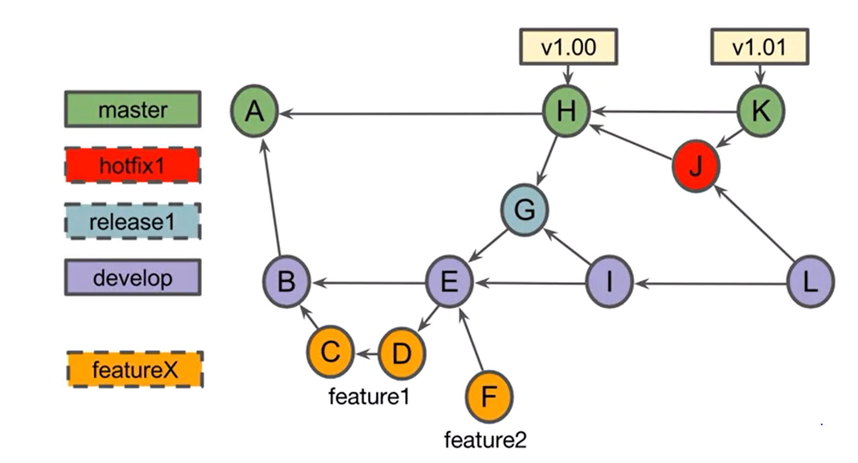

* The initial commit of the project is created on master branch.
* The develop branch is created off the initial commit.
* Commit B is the initial commit on develop branch.
* Create feature1 branch off the commit B
* Begins work and creates commit C
* Final work on feature1 is done by Commit D
* Team decides feature1 is ready.
* Merge CommitE is created adding feature1 to the project.
* Feature1 branch label can be deleted.
* Team decides Commit E is a release candidate.
* Creates a release 1 branch off the commit E.
* Developer creates feature2 branch and creates commit-F.
* The team discovers a bug in commit E.
* Creates Commit-G on the release1 branch.
* This commit fixes the bug.
* Commit G is approved.
* Create merge commit H
* Tag commit H with v1.00
* Create commit Merge I on develop to incorporate bug fix on commit G.
* Release1 branch can be removed.
* Bug with version 1 release create hotfix1 branch.
* Create commit J to fix the issue.
* HotFix J is merged into master k. Tag v1.01 placed on commit k.
* Hotfix is merged into develop L.
* Hotfix1 can be deleted now.
* Work continues on feature2 for next planned release.
* Only merge commits on Master. Commit to master only from a release or hotfix branch. If you commit to master also merge into the develop branch.